**T E C H N I C A L I N F O R M A T I O N**

**Crank Sensor operation on turbo Buick engines**

Probably one of the most confusing systems on the turbo Buicks is the CCCI ignition system. But it’s actually pretty simple once you understand it. This article will explain the Crank sensor portion of the system.

The Crank sensor uses a “Hall-Effect” switch which closes when it senses a magnetic field. When you break the magnetic field (when the interrupter blade passes thru the field), the switch opens. This sensor basically sends a ground signal to the CCCI (**C**omputer **C**ontrolled **C**oil **I**gnition) module when the engine rotates. On the harmonic balancer assembly, there is an interrupter wheel with three slots cut into it. When the open slot passes across the sensor slot, the sensor switches to ground, sending a pulse to the CCCI module. As the engine rotates, three evenly spaced pulses are sent for every revolution of the crankshaft. Since the CCCI has three ignition coils, each pulse directs each of the three coils to fire sequentially; once for each cylinder as it hits its compression stroke. There is also a “waste spark” at the opposite cylinder which happens during the exhaust stroke, and has no effect on the engine’s operation.

There were a few different designs used between 1984 and 1987. The first design in 1984 used a shrouded interrupter slot and a pigtail with a Weatherpack® style connector. The sensors were powered by a filtered 12 volt supply from the module. The connector pinouts were A – Positive 12V, B – Signal, and C - Negative:

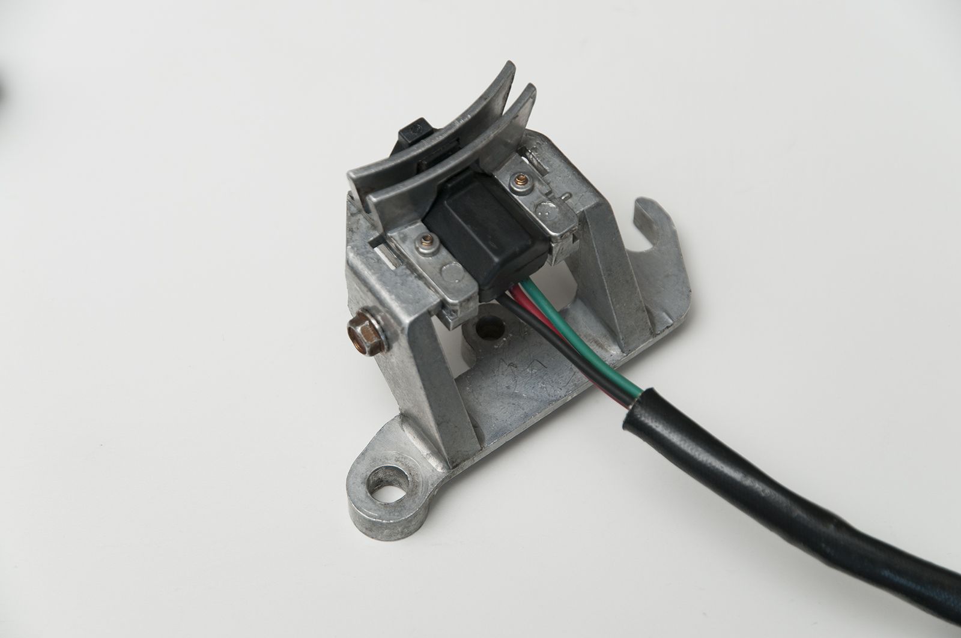

In 1986, the intercooled version of the engine saw a design change of the CCCI and utilized a new design of the Crank sensor using a Metripack® connector. This was the early 1986 design. The pin outs, however, changed: A – Positive 12V, B – Negative, and C – Signal:

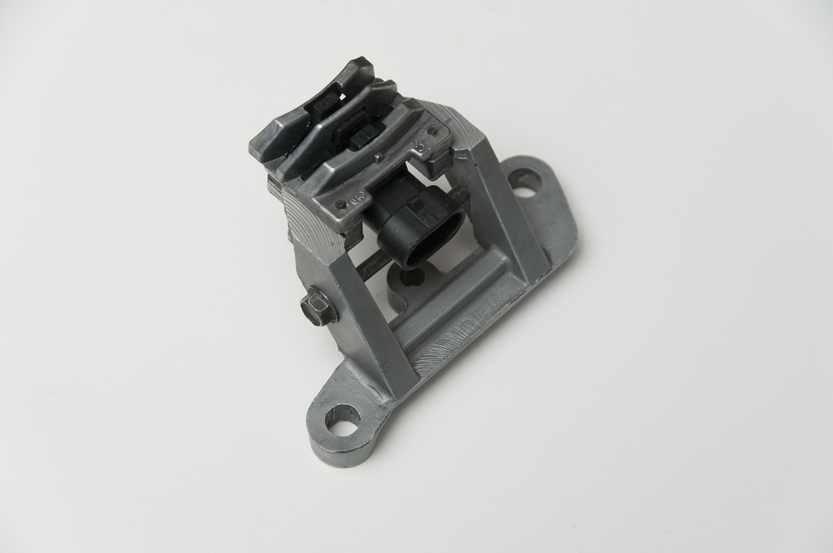

This early design was subject to failure because there were multiple components that would loosen and cause the sensor to break and fall apart. So, in early 1986 production, GM released a 3rd. design for better reliability, using less parts:

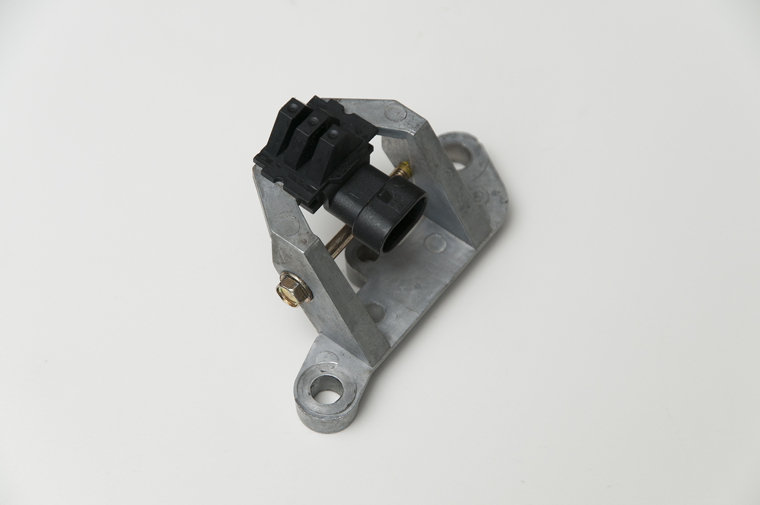

To complicate things, GM, in its infinite wisdom, shifted the color codes in 1986. Prior “hot air” cars used a gray with red stripe to designate a positive 12V feed and green to designate a signal wire. Black was always a negative (ground) wire. The signal wire now became the gray with red stripe, and the positive became the 12V feed! This anomaly has been the source of much grief when the original 1984-1985 ignition parts became obsolete and unavailable. It should be noted that if your car is the 1984-1985 production model, and you found the need to replace the ignition module, you would have been informed that the original design module is no longer available. So, your next step would be to use a later, 1986-1987 style module in its place. The connectors are the same; the only difference is the mounting studs; the early style module used four studs, the later uses three.

**If you install the 1986 style CCCI module into the 1984-1985 vehicle, you will *instantly***

**burn out your original Crank sensor, and the car will never run. You need a special adapter.**

To further complicate things, GM swapped not only the Crank sensor wire colors, but also changed the pin-outs on the CCCI module. In the process, the Positive and Negative feeds to the Crank sensor were reversed, leading the way to immediate damage to the component if the wrong CCCI module were installed. Also, the need for a current-limiting resistor wire internal to the early engine harnesses was eliminated.

The currently available sensor looks like this, fits into the bracket, and the interrupter MUST be installed with its wheel in the proper groove, as shown here:

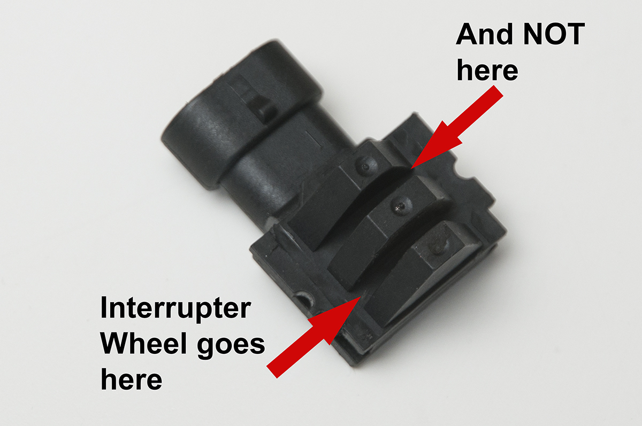

There are special adapters available for installing the later-style CCCI module on your 1984-1985 engine, along with specially made Crank sensors for those years. As a side-note, the Cam sensors remained unchanged throughout the years.

HOW DO I TEST A CRANK SENSOR? This question has been posed many times. A simple tester using two resistors, a connector, a battery and an LED can be fabricated as shown in this image. You can simply plug it into the sensor and the LED will light when the sensor is unblocked. Slide a flat-blade screwdriver thru the outer slot, and the LED will turn off:

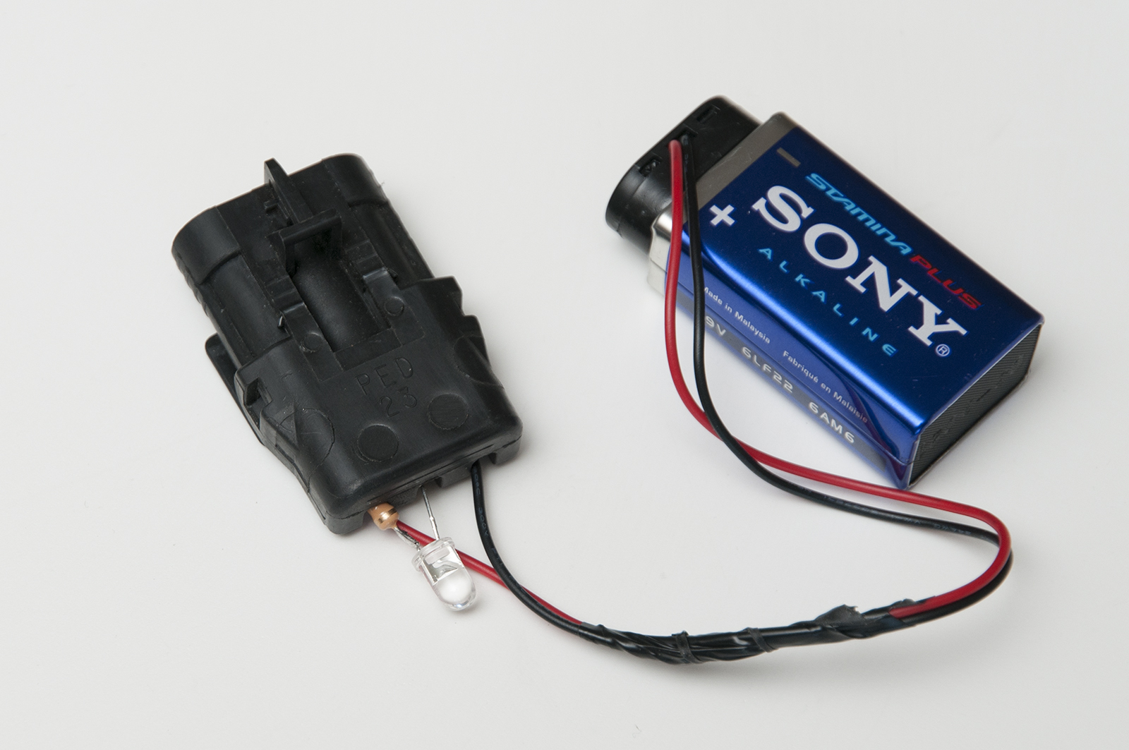

I will just touch on the CCCI pinouts. There are 14 pins in the sealed connector attached to the module. Here is the layout for the 1984-1985 CCCI:

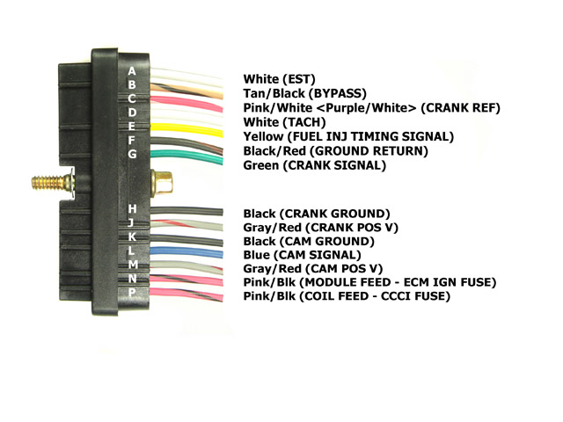

And this is the 1986-1987 CCCI. Note the difference in Crank Signal and Crank Ground colors:

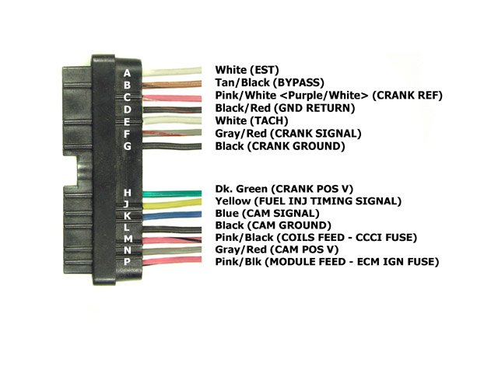

Copyright ©1989, 2005, 2015 Casper’s Electronics, Inc. All Rights Reserved.