I N S T A L L A T I O N I N S T R U C T I O N S
GNX Dash Conversion to Digital-Dash Equipped Regal
This instruction sheet deals primarily in wiring issues. The GNX dash cluster was originally designed for installation into a standard analog-dash Regal GN. When installing into a vehicle equipped with the optional digital dash, the following is modified to accommodate the correct wiring. The adapters shown below will provide correct wiring to the gauges of the GNX dash. There are two major differences between the standard analog dash car and the digital dash car. One, there is no tachometer signal available in the passenger compartment dash area, so you must add a wire from the tach signal on the engine wiring harness to provide a suitable signal to the tachometer. Second, the analog dash cars had a “Tach/Boost” display on the dash, the digital dash did not, so there is no connector for the tach/boost module. There is, however, a connector that is specific to the digital dash cluster, which provides a connection to the fuel gauge. To provide the correct wiring connections, both the C1 bulkhead connector and the special digital dash connector will be used.

When installing the GNX cluster, you first must remove the cluster cradle
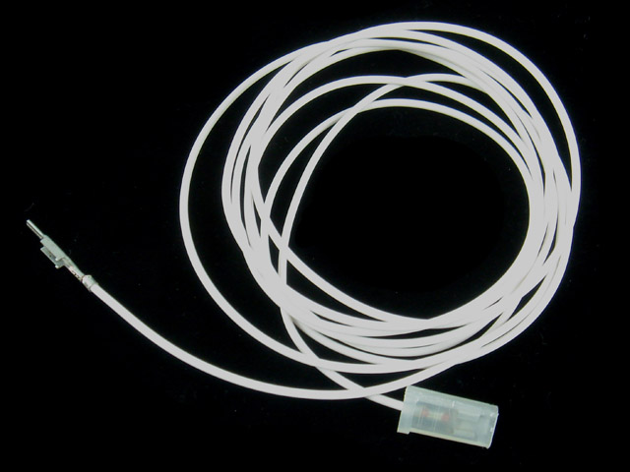
from the vehicle, then remove the plastic material (shown in red).
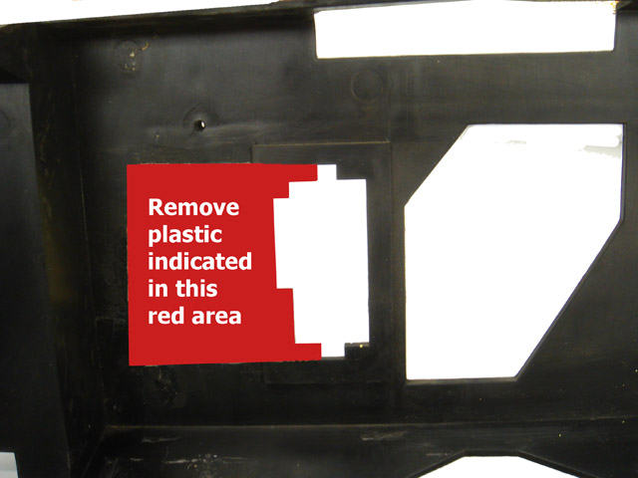


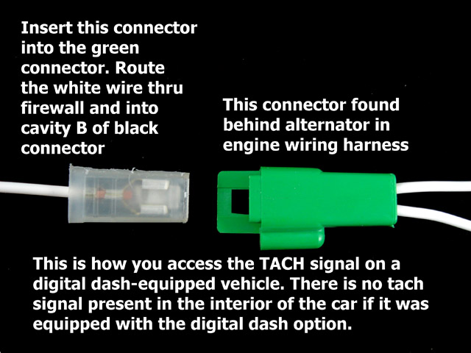
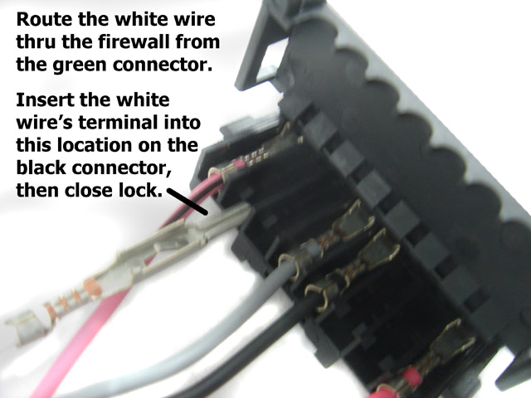
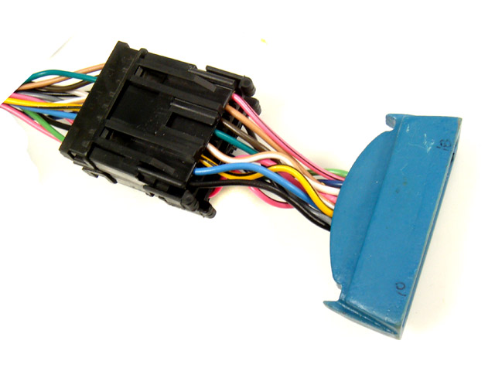
C1 bulkhead connector for digital dash cars is wired differently than the standard analog dash bulkhead.
Plug this into the blue receptacle and secure with cable ties.
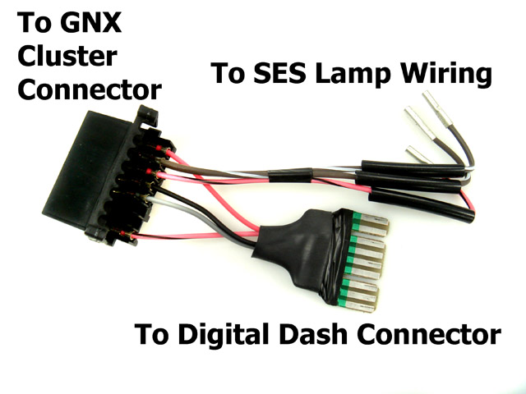
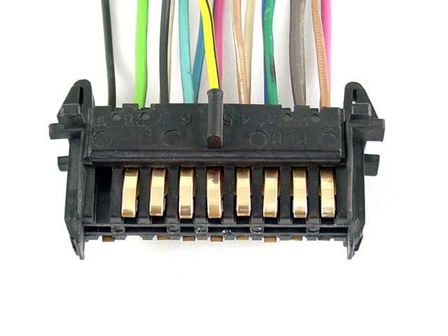
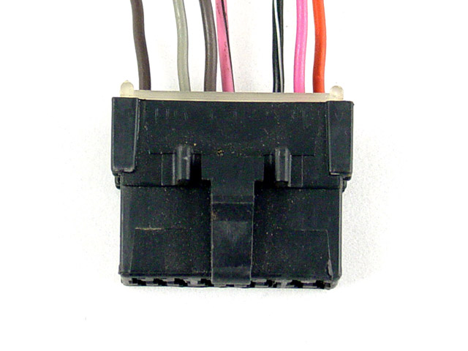
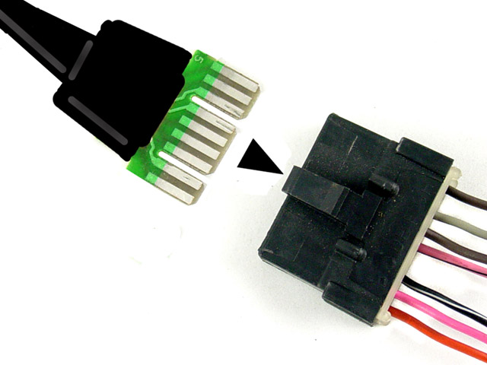
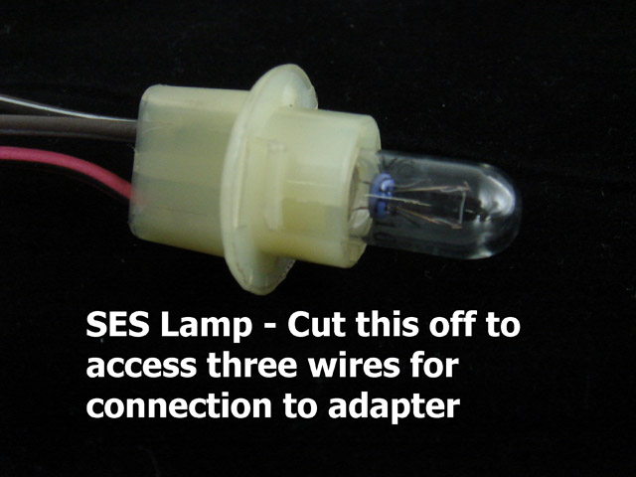
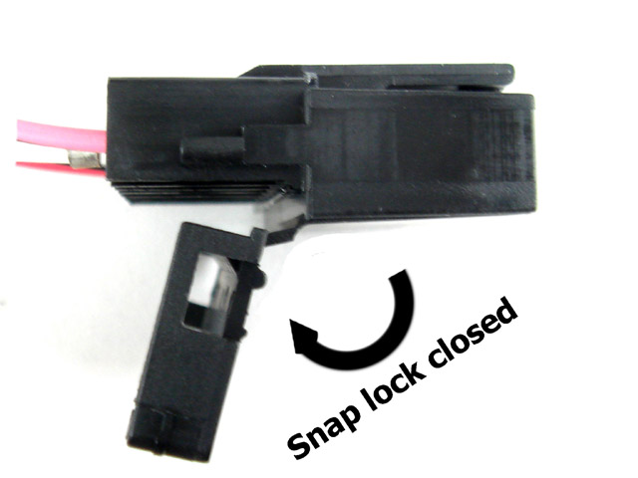
TACH feed wire must be fed thru firewall. Use speedo cable grommet.
Digital Dash electrical connector is exclusive to digital dash cars.
This adapter is added to the GNX cluster wiring and provides the gender wire changes necessary. Note the swapped colors facilitated by the black connector.
Insert adapter plug as shown here.

